**SG Technologies**

**User Manual**

**Nov. 19, 2015**

1. **Introduction** 
   1. **Scope and Purpose**

SGT POS will be a computerized application used in different retail stores that will record sales and handle payments (process sale), process rentals and handle payments (process rental), and handle returns and refund credit (handle return). The POS will be efficient, elegant and easy to use on surface level (cashiers) as well as administrative level (managers) but also include services such as an off-line mode, a third-party tax calculator and inventory control that will make it top of the line.

**1.2 System Overview**

*Current Functionality*

* Record sale and handle payment (Process Sale)
* Process rental and handle payment (Process Rental)
* Handle return and refund credit (Handle Return)
* Payment authorization
* Support manual inputs of item ID or barcode
* Interfaces to various service applications
* Off-line mode (capable of capturing sales and handling cash payment when offline)
* Administrative functionality including startup/shutdown and user management

*Improvements from previous version (alpha version)*

We added the multiple payment options. Cashiers are able to handle different payment methods from customers. If customers choose to pay by credit card, the system will ask for the credit card number and check if it is 16-digit number. If customers choose to pay by cash, the system will ask for the amount of cash and return the amount of change. We added the functionality of handling return unsatisfied items. We also applied the graphic model to the system. We fixed some logical problem in the system. For example, in alpha release, cashier cannot add items after deleting items. The adding items method and deleting items method happen sequentially. In beta release, they are parallel methods.

**1.3 Manual Organization**

Section 1 introduces the scope and purposes of the product, and gives a system overview.

Section 2 talks about the system requirements, configuration, and contingencies

Section 3 talks about how to use the application. This includes installation, GUI, log in and log off, and major functions.

1. **System summary**

**2.1 System configuration**

The POS involves in the interaction of six actors – customer, register, cashier, item, sales, and sale item line. There are five use cases – process sales, process rental, handle return, user management and system startup and shutdown.

**2.2 User Access level**

Unlogged users: None

Cashier: able to process sales, rental, and handle return, start and shutdown the system.

Admin: able to process sales, rental, and handle return, start and shutdown the system, as well as manage all the cashiers in the system.

**2.3 Contingencies**

If power is down during a transaction, the transaction will not be recorded. If the database is down, the System will alert the user and not allow the transaction

1. **How to use** 
   1. **Installation**

Users can install the software by downloading from Coursesite or Github. The application can be run in any Java integrated development environment software such as Eclipses and Dr. Java.

* 1. **GUI**

Run the project and the main interface for cashier after login will show as image below. 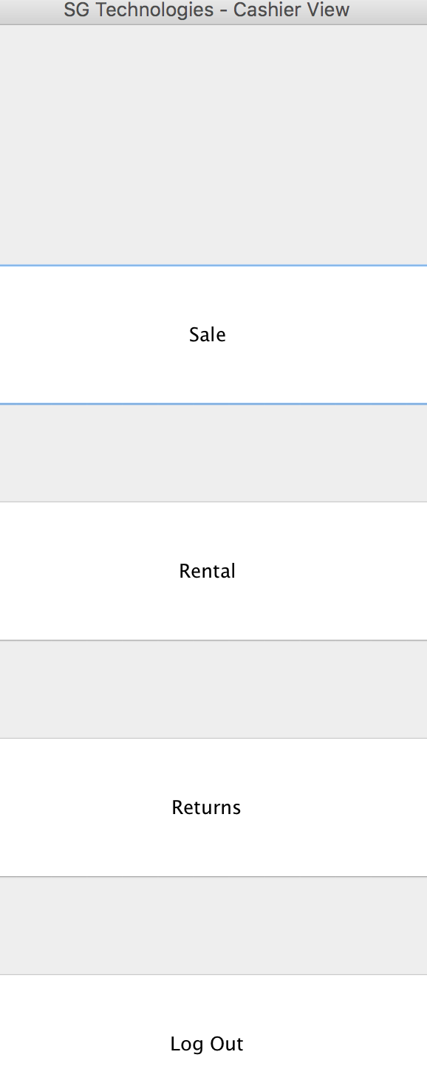

* 1. **Logging in**

Users can log in by entering the user name and password on the GUI. At this point, we have 19 valid employees who have access to the program. The employee information is shown on the employeedatabase. For example, one success log in is shown below:

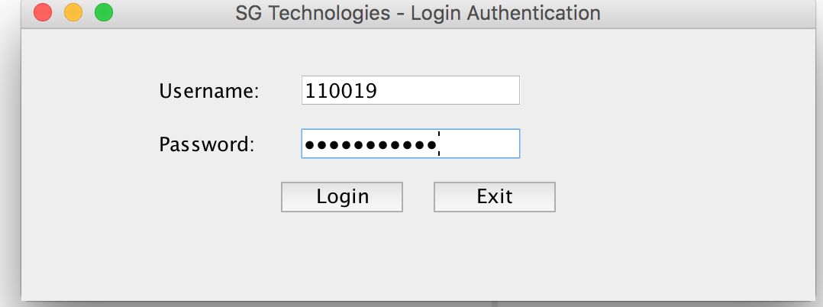The use name is 110019, which is a cashier named Christina Ryan. The password is philosopher.

**3.4 major functions**3.4.1 user management

In terms of user management, there are 4 admins in the program. The valid users should log in to the application, and the interface with options of add, delete, update employee will shown as below. 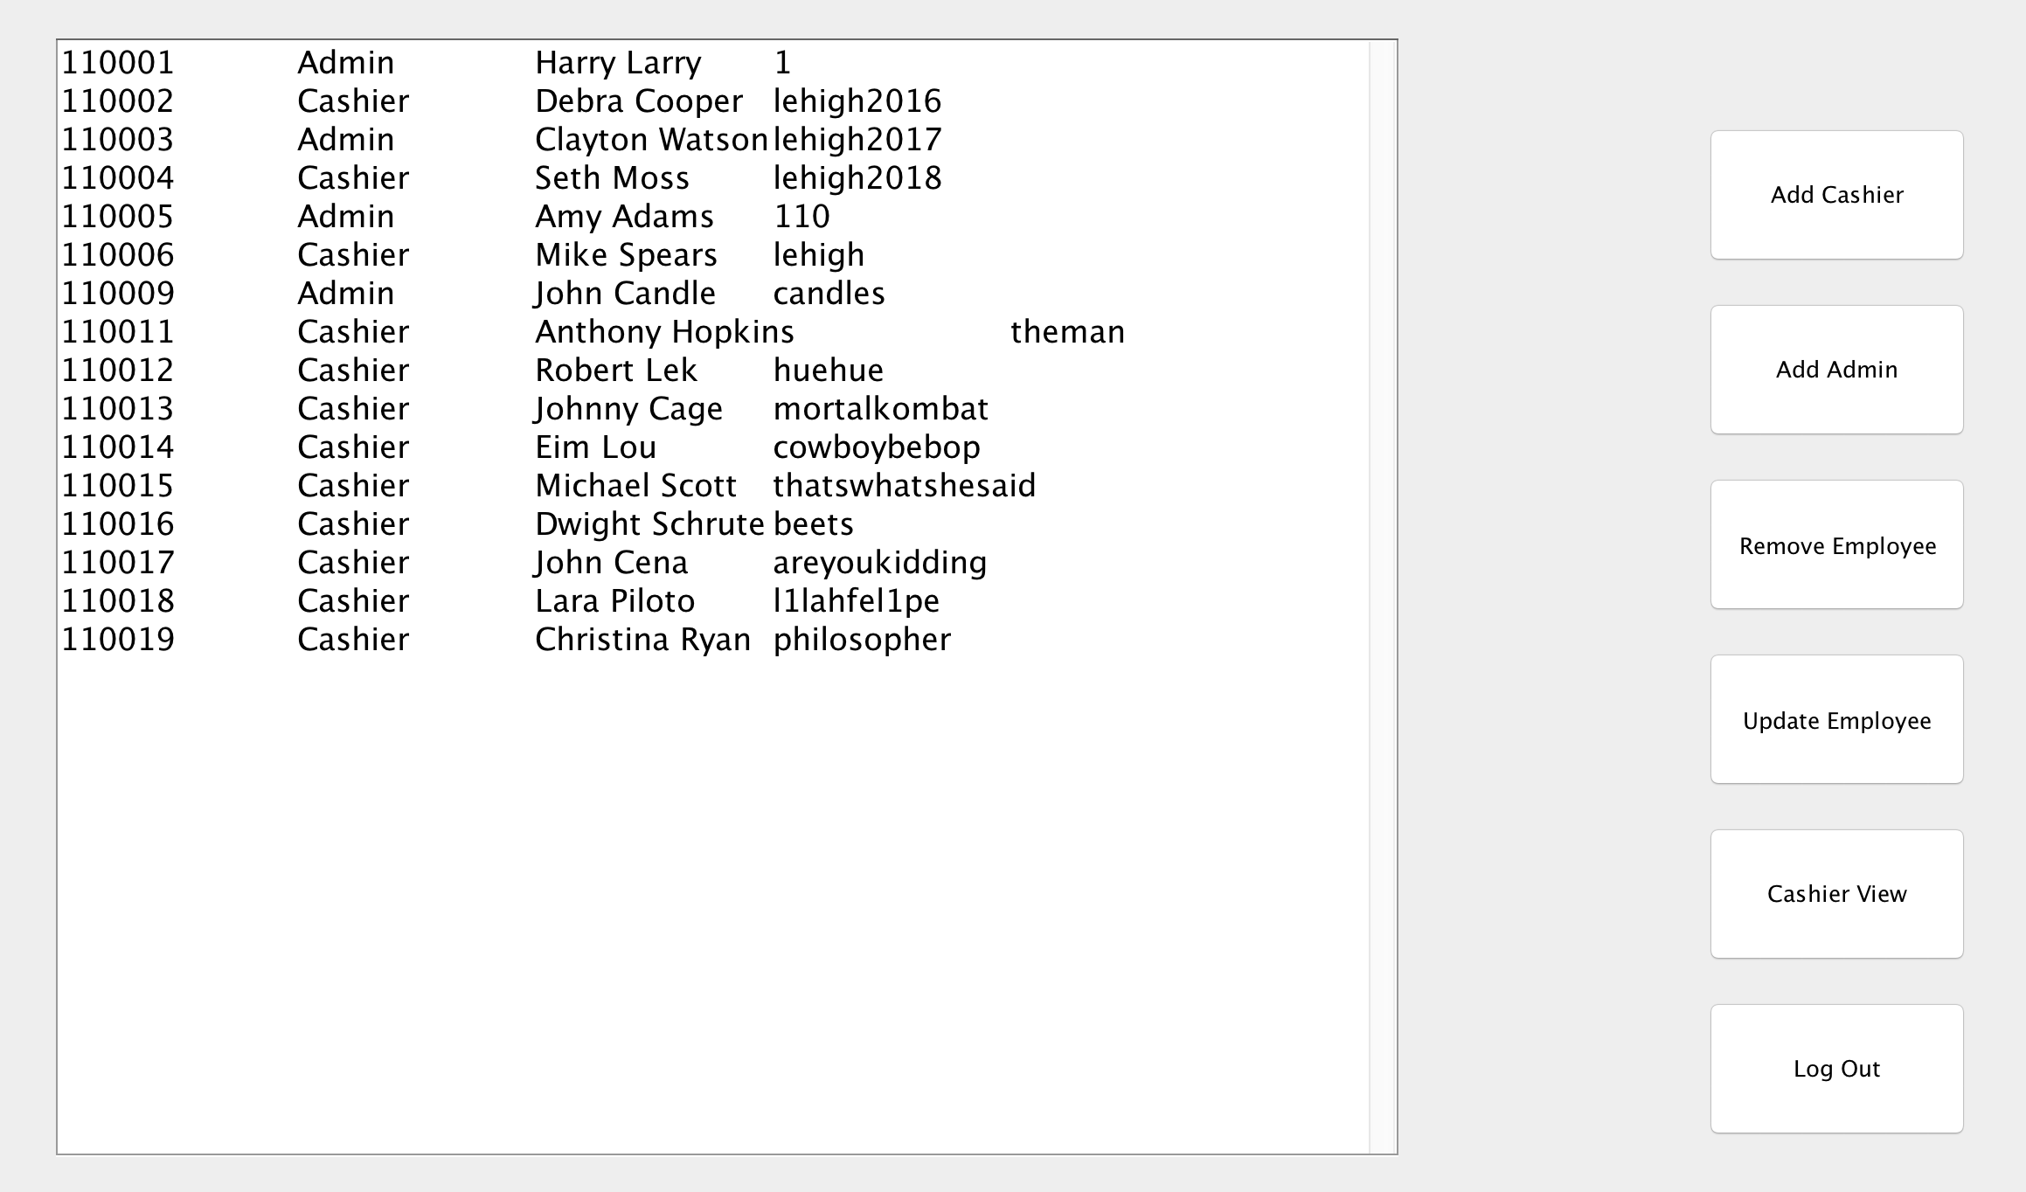  
3.4.1.1 add person

Click on “Add Cashier” on the panel on the right, and the application will pop out a page asking user to enter new employee’s name and password. In this case, we entered Donald Trump as a casher. Click Enter, you will see the information is added and displayed on the left. 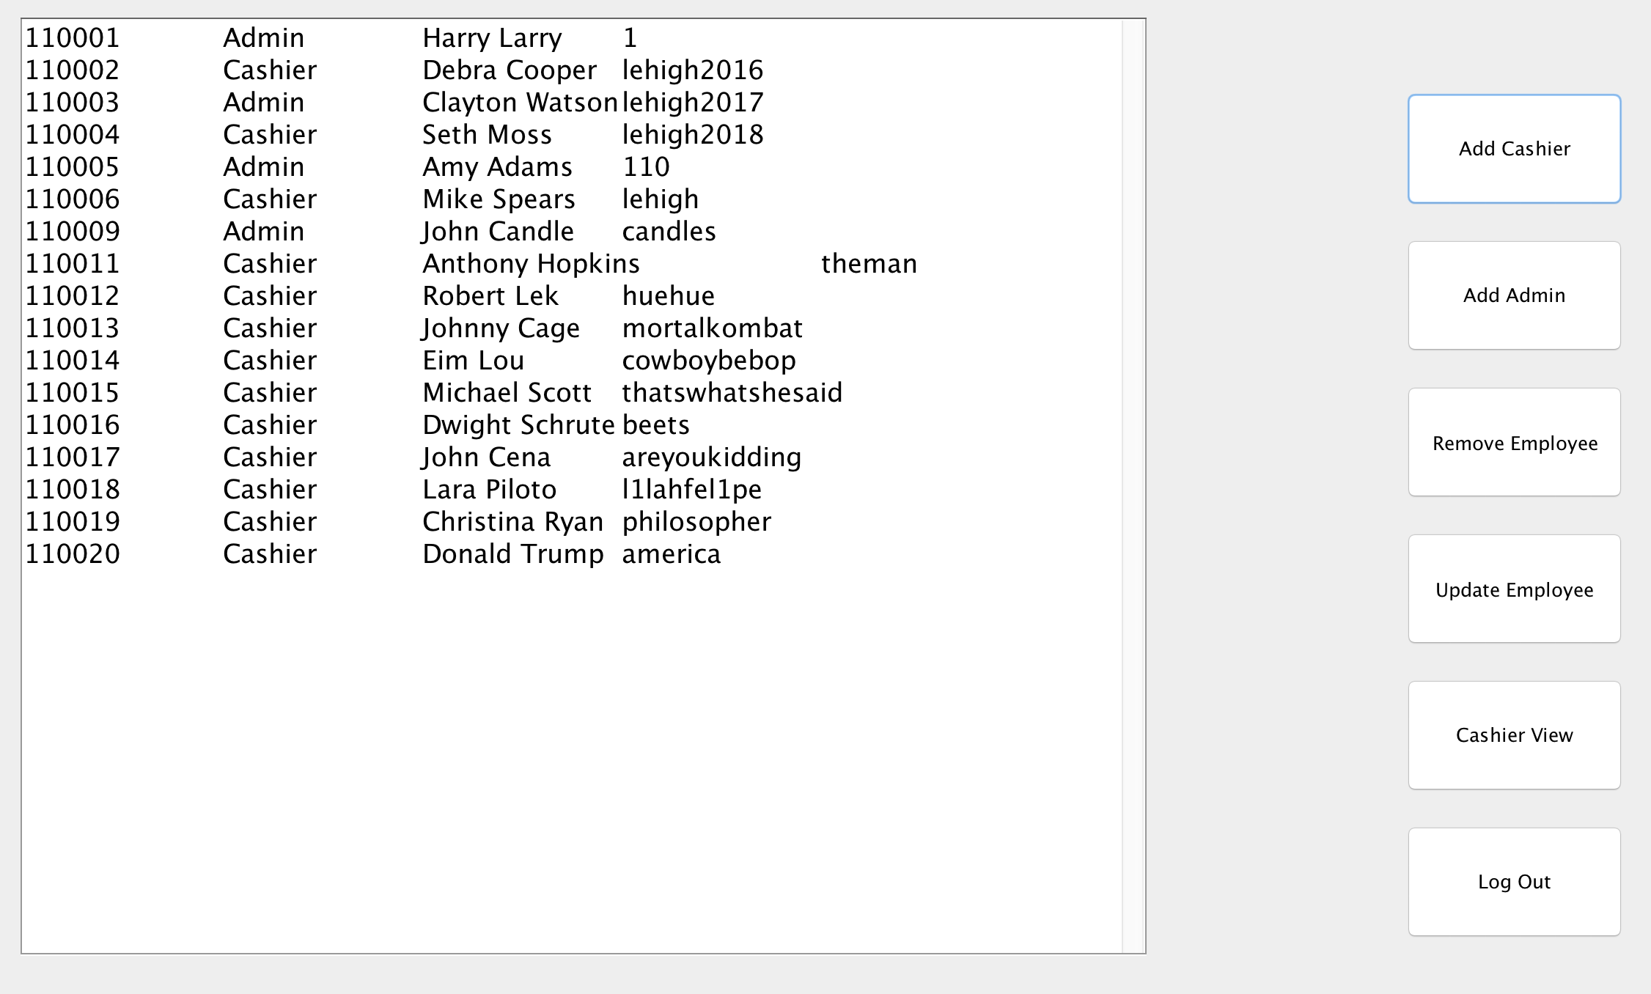  
3.4.1.2 delete person

Simply enter the employee ID, admin can delete the employee after entering the ID and click on enter.

3.4.2 process sale: how to do process sale using your POS system; introduce the signal of a successful or failed transaction. Introduce payment method for process sale.

*Enter item*

Users should go to cashier view, and click on sale button. The program pops up a dialog box asking users to enter Item ID and amount. The valid items can be found from itemDatabase file, and users should be able to retrieve such information for customers who purchased these items. After entering correct item id and amount, updated sales line item and total amount with tax should be shown on the left. If item ID is incorrectly entered, a message box will show up saying “ Item not found on the inventory”.

*Coupon*

After finishing entering the items, cashier should click on “End” to go to the next phase. The program will ask you to enter coupon if customer has any. In this case, there are 200 couples, from C001 to C200. This information can be found at text file CouponNumber.

*Cash*

After coupon is applied, customers should be able to should pay by cash or credit card. If paying by cash, cashier should enter the amount that customer gives. If it’s not enough, the application won’t proceed. If it is enough, change is calculated and shown in a dialog box. Then cashier should click okay and confirm the sale.

*Credit card*

If the customer decided to use credit card, system will ask the cashier to enter credit card number. If the credit card is 16 digits number, the program proceeds. Then the program asks if customer wants to get some cash back and calculates totally amount collected, cashier conforms payment if everything is correct.

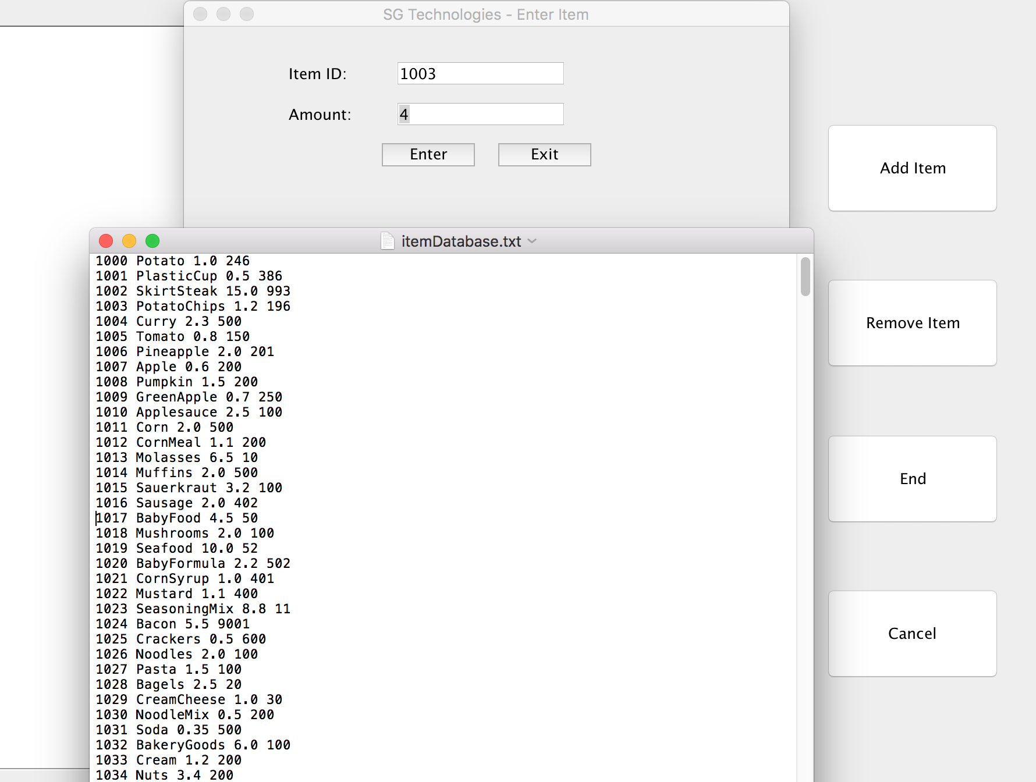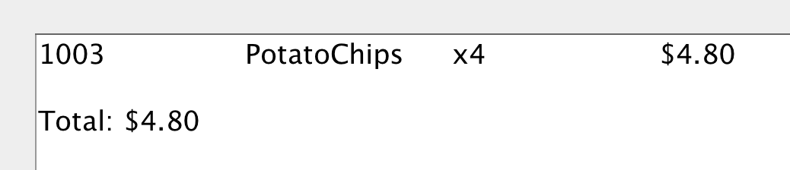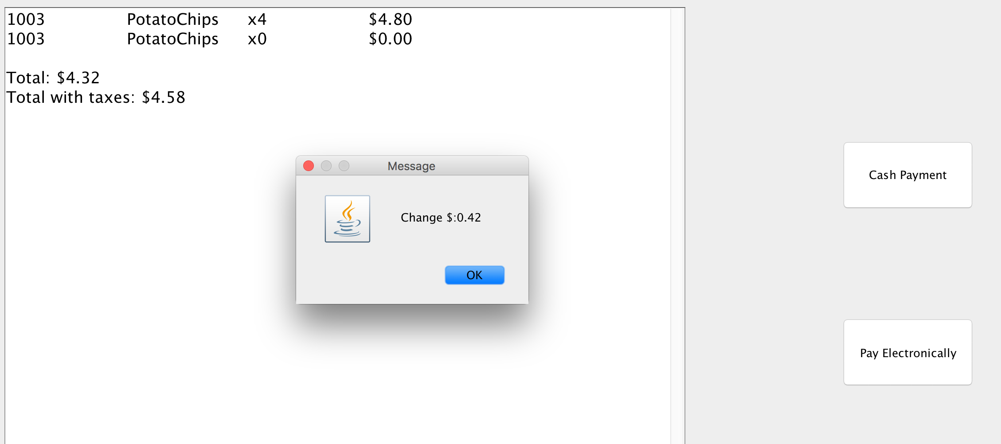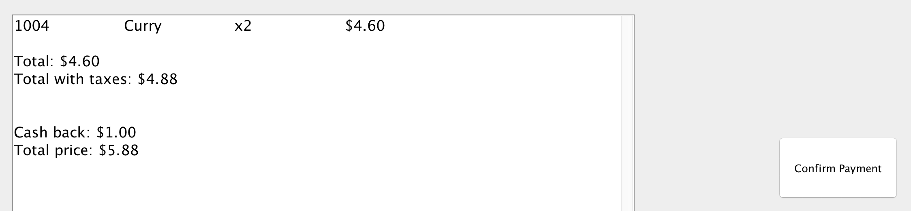  
3.4.3 rental sale

Cashiers should select the rental option on the main interface, and then enters customers’ phone number. This information can be found in user database. For a successful scenario, a valid number is 4123849394. After entering the number, cashiers could select add item to add items. Valid rental item information can be found in rental database. For a successful scenario, we can enter 1004 and amount 2. The information will be reflected on the left. The cashier should click on end when all items are entered, and then select cash or electronic payment. After payment is proceed, the information of totally payment, change if by cash, and return data will be shown on the left. 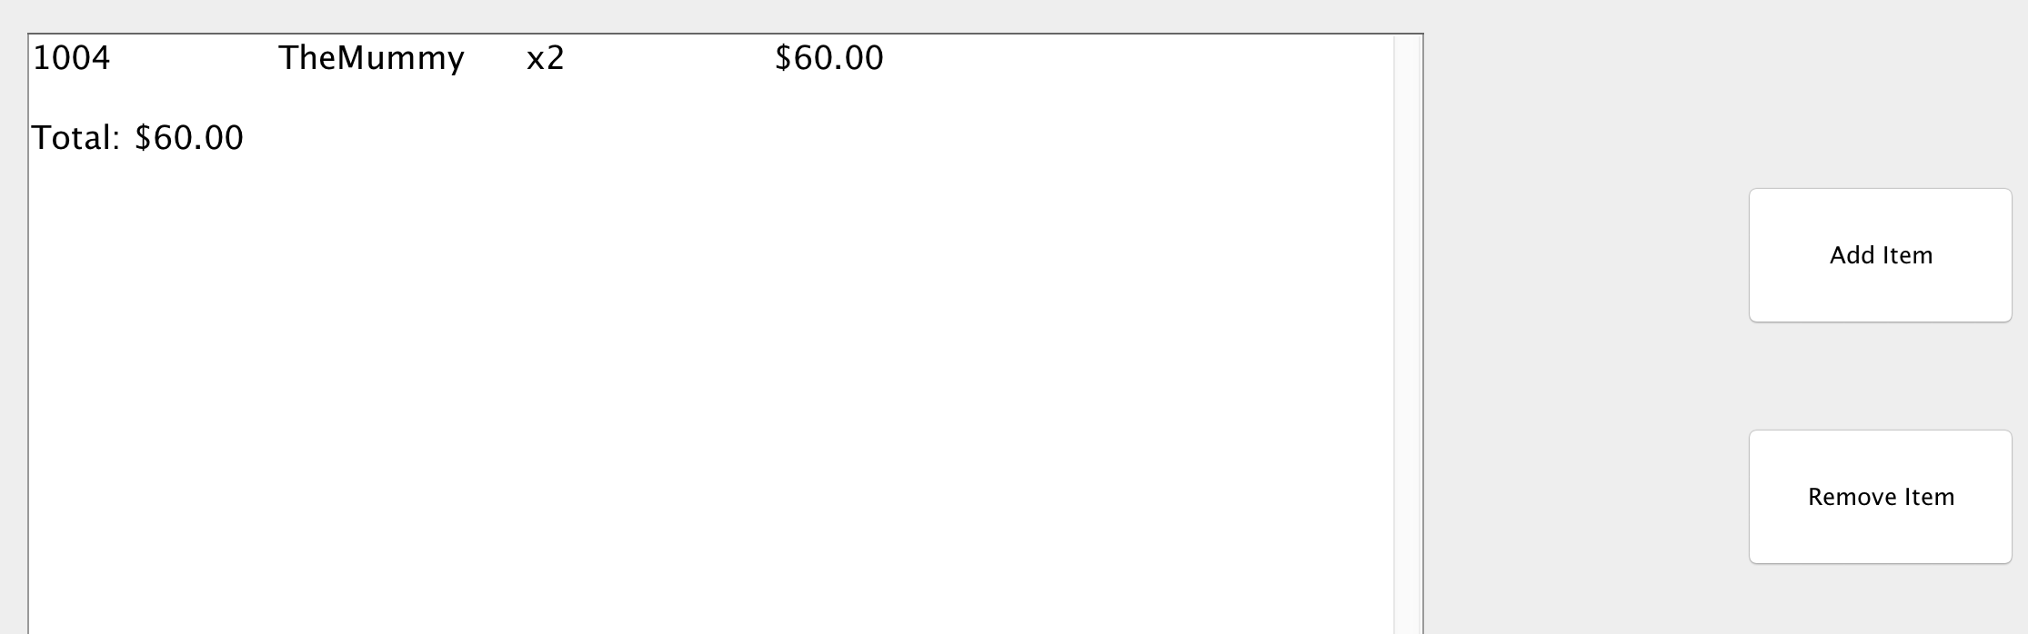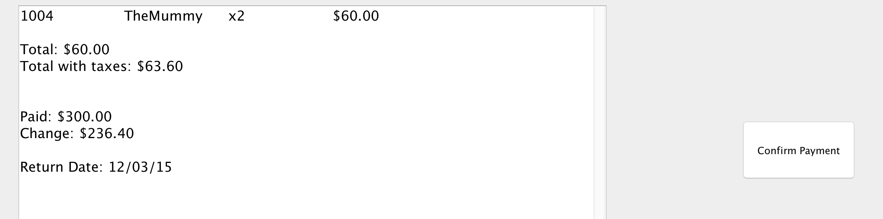  
3.4.3.1 rules for charging and payment method

|  |  |  |  |
| --- | --- | --- | --- |
| Rule ID | Rule | Changeability | Source |
| 01 | Purchaser discounts are set by the retailer’s policy. | Very low since every retailer’s policies are usually different from one another. | Retailer policy. |
| 02 | All credit payments require a signature from the buyer. | Some sort of “signature” from the buyer will always be required. But in the future, customers will demand newer technology to be available such as digital capture devices. | Common credit authorization company policy. |
| 03 | All sales require added taxes. More information on taxes can be found on the government statutes. | Very high since tax laws change frequently. | Law. |
| 04 | Product discounts and sales are also set by the retailer’s policy. | Very low since every retailer’s policies are usually different from one another. | Retailer policy. |
| 05 | Company policy dictates that credit payment reversals may only be paid as a credit to the buyer’s credit account. | Very low. | Company policy,  credit authorization. |
| 06 | The moment that an electronic debit or credit payment is approved, the payment authorization service is responsible for paying the seller, not the buyer or the company. | Very low. | Company policy |

3.4.4 return

In order to return items, cashiers must ask for users’ phone number. A successful scenario will be 6096515668, and then the system pops out a box asking cashiers to select returning renting items or unsatisfactory items.

*Rented items*

This customer rented item 1001 and 1022. After cashier selected rented items, POS will have a page shown amount due. From there, cashiers can follow the payment process to proceed on which method to return the money to.

*Unsatisfactory items*

Cashier enters the item number, and POS will show how much the total return payment should be. From there, cashiers can follow the payment process to proceed on which method to return the money to.

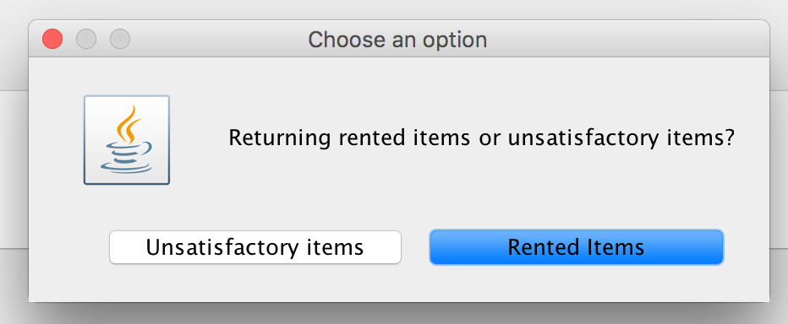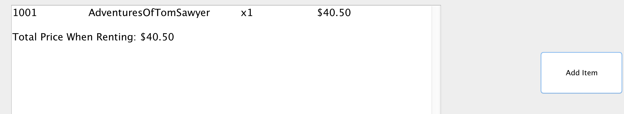  
**3.5 logging off the system**

To log off from the system, simply click on the Log Off button. It will take users to the log in page, and user selects exit to exit the system.